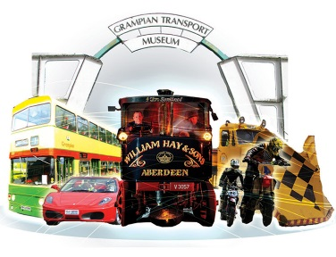
ALFORD AUTOJUMBLE & CAR BOOT SALE
Sunday 28th April 2019
Please complete in full and return by Wednesday 17th April. Once payment has been received you will be sent confirmation of booking and a welcome pack containing further instructions and information for this event.

Name: ……………….……………………………………………………………………………………………………..…

Address: ……………….……………………………………………………………………………………………………..…

Postcode: ……….……………………………………….. Telephone: ……….……………………………………..

Email: …………………………………………………………………………………………………………………………
Please tick this box if you do wish to receive updates by email

Price per pitch

£12.00 (non-members) £6.00 (GTM members)
Please tick Membership number ……………………
Number of pitches ……………………… Payment of £ ……………… is enclosed
(Cheques payable to Grampian Transport Museum)

Intended use of pitch

Sale of Vehicle Sale of Vehicle Miscellanea
(Including spares, parts, memorabilia etc)
Make ………………………………
Model ……………………………… Trade/Craft Stall
Further details: ……………………………………
Reg ……………………………… ………………………………………………………

Sale of Household jumble Club/Group Fundraiser Stall
(General household items) Further details: ……………………………………
………………………………………………………

Please specify brief details of any special items/vehicles intended for sale which you would be happy for us to use in promotion of this event.

……….………………………………………………………………………….…………………………………………………………….………………………………………………………………………….……………………………………………………
Information regarding pitch

- Allocated pitch with frontage of approximately 20ft
- Two complimentary passes for entry to Museum on day (usual cost £19)
- Traders entry to site between 7.30am and 8.30am on day
- Restricted to One vehicle per pitch and maximum of two persons per pitch

Pitches may be allocated on the day at cost of £15.00 (non members) or £7.00 (GTM members), please note however these will not be issued with complimentary passes.

Please note that it is illegal to knowingly bring any items containing any form of asbestos. Our asbestos marshal will be on site at the event and will be monitoring for any items containing asbestos. No flammable/restricted fluids/items should be sold. Open to public 9am – 3pm

GRAMPIAN TRANSPORT MUSEUM | Alford | AB33 8AE
Tel: 01975 562292 Email: events@gtm.org.uk

