Cycling Facts

THE FIRST BICYCLE

- The cycle possibly owes its origin to the child’s toy, with a horse’s head on one end of a pole and a wheel on the other. This was known as a ‘Hobby Horse’.
- The first use of two wheels in line with steering is credited to Baron Karl von Drais, a German civil servant, in 1817.
- Karl von Drais called his invention a ‘Laufmaschine’ or running machine as the rider propelled the simple device forwards with his legs.
- By the spring of 1819 the ‘Draisienne’ was causing much interest in London and British copies started to appear, popularly known as the ‘Hobby Horse’.
- The best British copy was by coach builder, Dennis Johnson, of Covent Garden, London. This was a much improved and more elegant machine with a curved spine, lower seat and larger wheels.
- The Hobby Horse became, briefly, a fashion craze in London society, adapted by the Regency dandies and was often referred to as the ‘Dandy Horse’ at that time.
- The craze began to dwindle by the mid 1820’s as the machines were surprisingly expensive at £10 each and the ‘dandies’ were regularly fined £2 for riding on pavements and footpaths.

THE ‘SCOTTISH SCHOOL’

- 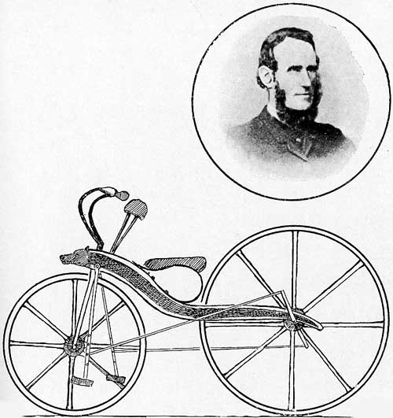Between 1839 and 1841 a country blacksmith from Dumfriesshire, called Kirkpatrick Macmillan (1812 – 1878), is credited with building an improved Hobby Horse using a system of lever treadles to drive the back wheel.
- Macmillan is often described as the inventor of the bicycle. He certainly built the first, or one of the first, bicycles with driving gear instead of the rider pushing with his legs.
- Macmillan was not alone; Lesmahagow’s Gavin Dalzell built a similar machine in 1846 and another Dumfriesshire man, Thomas McCall, copied Macmillan’s ‘Velocipede’ making several machines between 1871 and 1896.
- Macmillan and the early ‘Scottish School’ of cycle makers had the right idea in driving the rear wheel leaving the front wheel free to steer. However, their method using cranks and links was clumsy. If they had used sprockets and chain there may not have been a forty year era of front wheel drive ‘Boneshakers’ and ‘Penny Farthings’.

THE CYCLING BOOM

- In the early 1860’s Pierre Michaux (1813 – 1883), a pram maker in Paris, working with his son, Ernest, began to sell a bicycle with pedals and cranks driving the front wheel spindle. They called this their ‘Velocipede’. The actual patent was registered by their chief mechanic, Pierre Lallement.
- By 1865 Velocipedes were selling in France at the rate of 400 per year.
- The Coventry Sewing Machine Company began production in Britain in 1866 intending to sell the machine in France but the outbreak of the Franco-Prussian War stopped the French sales, so the Coventry machines were marketed in Britain and became known as ‘Boneshakers’.
- By 1868 Boneshakers were selling fast and competitions and cycling rallies began to draw huge crowds. The first cycle race was run in Paris, won by Englishman, James Moore, and in that year the Crystal Palace cycle race track opened.
- In Scotland, William Flint, demonstrated his ‘Parisienne’, a Velocipede built by Michaux, in front of large crowds in Edinburgh’s Princes Street in 1869.
- In Britain huge improvements to the Coventry Sewing Machine Company’s bicycles, under the direction of designer, James Starley, led to a gradual evolution of the ‘Boneshaker’.
- Starley provided a mounting step and raked forks and with his Ariel bicycle of 1870 introduced tensioned wire spoked wheels with steel rims that held a solid rubber
tyre. At this time the front wheel was 48 inches in diameter with the rear wheel about half that size.
- In 1873 Dan Rudge of Wolverhampton built one of the first of a new type of bicycle with a very much larger front wheel to raise gearing and hence top speed. The high ordinary or ‘Penny Farthing’ had arrived.

CYCLING BECOMES SAFER

- 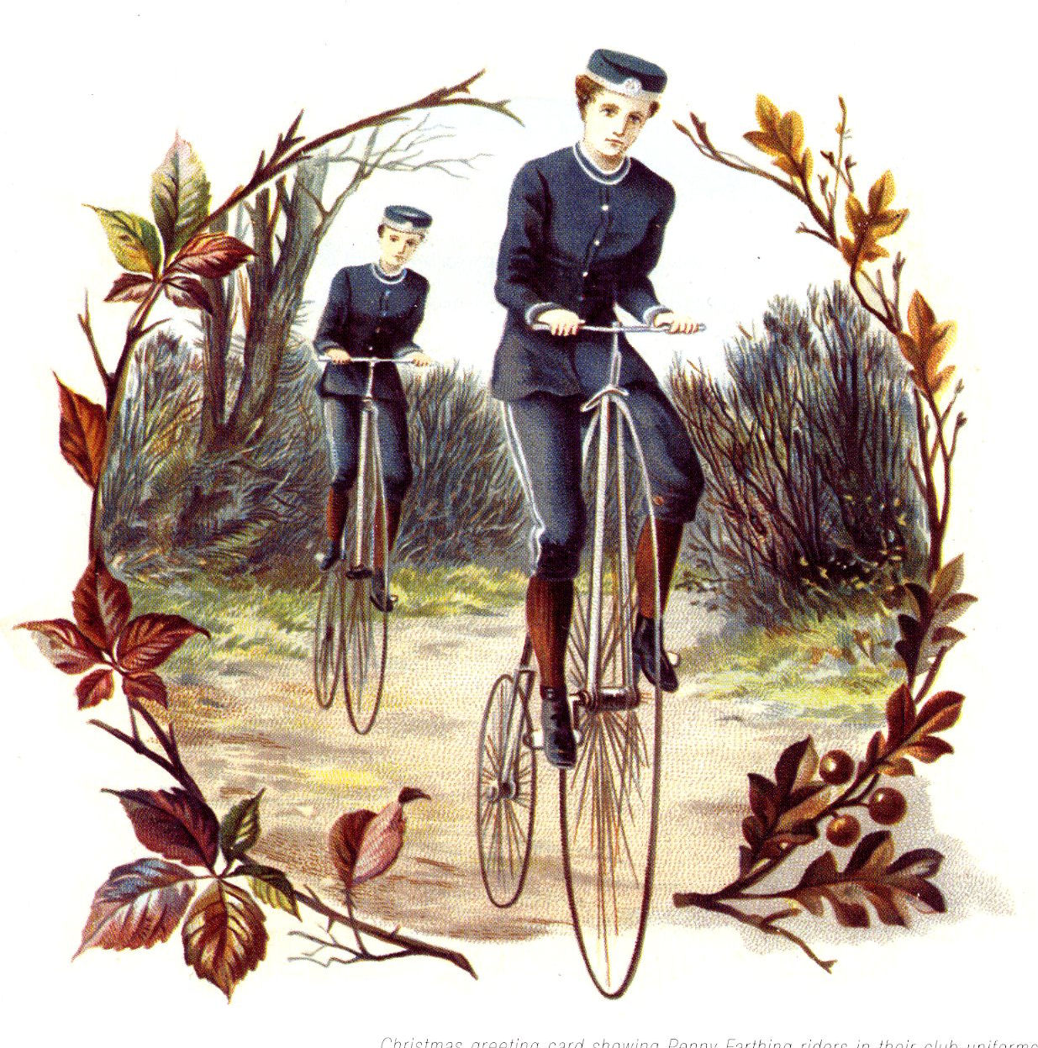Penny Farthings were so popular that development of other designs almost ceased. They were a Victorian craze. The speeds were very high and so were the dangers! The big wheel grew to 60 inches. A ladies side saddle version was released by Starley under the Ariel brand in 1874.
- Lightweight racers followed with ball bearings and strong tangentially spoked wheels and Bayliss -Thomas (later known as Excelsior) pioneered hollow front forks. In 1880 the Matchless made by the Collier brothers used hollow tubes and wheel rims while the Rudge of 1884, winner of many international cycle races, weighed less than 22lbs.
- Only the athletic and fearless could really master a Penny Farthing and survive the regular ‘headers’: accidents that involved head first descents to the road.

- By 1893 the high ordinary had been replaced by less high designs in the interests of safety. The ‘Facile’ used cranks to achieve gearing with a smaller wheel and the Crypto Cycle Co. made a small geared hub fitted first to a ‘Dwarf Ordinary’ of 1888 and in 1892 to their ‘Crypto Bantam’ producing a miniature machine that also boasted the new Dunlop air filled cycle tyre.
- There were several experiments with chain drive to the rear wheel and smaller wheels before the ‘Rover’, made by Starley and Sutton, found the winning formula in 1885. This machine had same size front and rear wheels, an adjustable seat and handlebars in the modern position. It sold well and was the first successful safety cycle.

THE SAFETY CYCLE DEVELOPS

- By 1889 only 12% of all cycles were Penny Farthings or ordinaries, 54% were safety cycles and 27% tricycles in various forms. By 1893 the ordinary had vanished and safety bicycles made up 85% of all cycles and tricycles had dropped back to 6%. Almost all the ‘safeties’ now had ‘diamond’ triangular frames, chain drive to the rear wheel, same size wheels and pneumatic tyres.
- Stonehaven’s R W Thomson had patented air filled tyres back in 1845 but his design was for carriages and heavy vehicles. His products were expensive and never went into volume production. In 1888 John Boyd Dunlop patented a cycle tyre that used a rubber air filled hose to contain the air and an outer detachable wearing cover. Within three years his invention revolutionised cycles and the new motorcar, being fitted to 83% of cycles by 1893.
- By 1895 the bicycle had taken its familiar modern shape but gears, brakes, mudguards, hubs, bearings and materials have been constantly improved. As touring and racing gained in popularity machines became lighter, faster and stronger. Raleigh, with their ‘all steel bicycle’ of 1900, became the biggest bicycle maker in the world, one of many high output companies in Britain. Smaller more specialist companies like Rattrays of Glasgow also flourished with their sporting ‘Flying Scot’ machines.

CYCLING TO THE BI-CENTENARY

- Cycling is enjoying a new boom in popularity as sporting activity increases along with interest in health and fitness. Cycling is also sustainable and efficient as concern over the usage, cost and environmental effects of running a motor car come under scrutiny.

