HOW MANY ….… ARE THERE?

Can you find these different things in the museum and count how many there are? Fill in the blanks below.

- Craigievar Express wheels …………………………….

- Vehicles pulled by horses ………………………………

- Motorbikes (with 2 wheels) …………………………….

- Country flags …………………………………………………
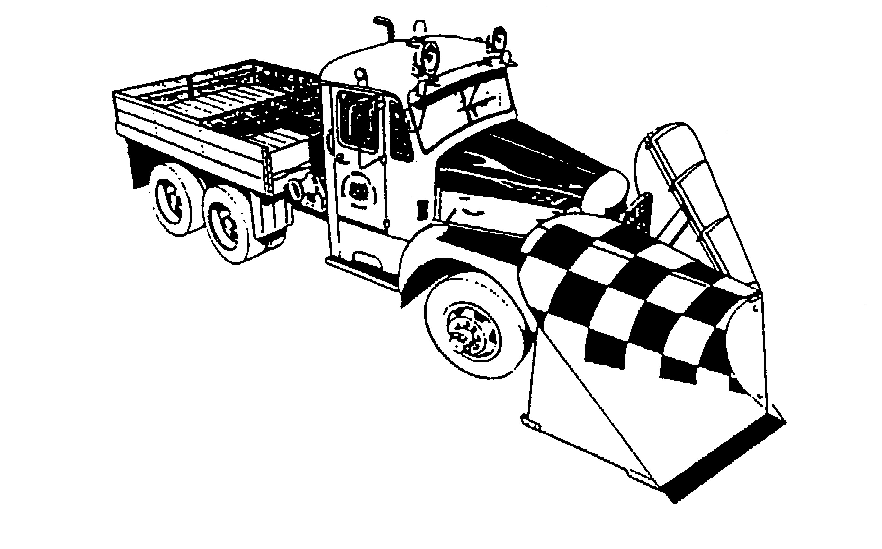
- Big Mack snowplough wheels ..........

- Caravans/campervans .………………..

- Electric cars .………………………………………….........

- 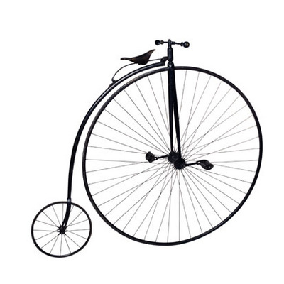Cats eyes in the tunnel upstairs ….......................

- Penny Farthings ……………………………
(High Ordinary cycles)

- Model locos in the showcase …………

When finished return to the Reception
to see if you have spotted them all
GOOD LUCK!

