MORTIER DANCE ORGAN IN FINE TUNE
This magnificent fairground dance organ was built in Belgium in 1923 and was moved around local halls in the North East. It is now the only one remaining in Scotland. The ornate facade is constructed in pine framework panels to allow ease of assembly while lime wood is used for the many elaborate and decorative carvings in an Art Deco style. The paintings of the young women on the facade represent the daughters of the original builder.
The workings of the organ are mounted on the rear of the facade. It was rebuilt in the 1940’s when the drum kit was added. The organ air bellows are now operated by electric motor but originally turned by hand.
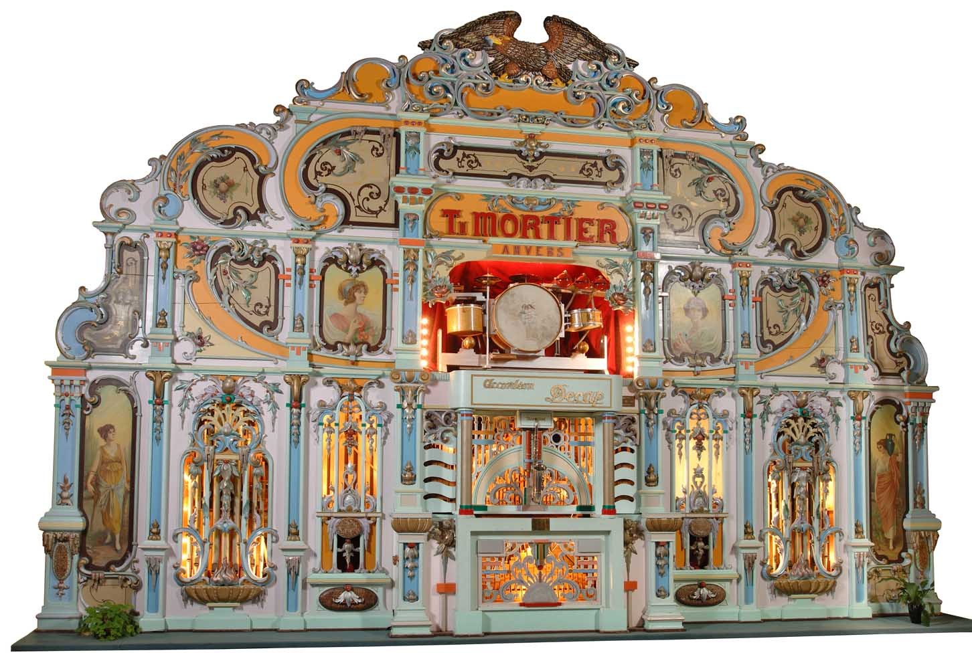The organ arrived in a small furniture van and has been under renovation for the last 12 years largely funded by generous donations which are still welcome. Over this last winter extensive detailed work has been undertaken including replacement drum skins to match the original and retuning the pipes. The organ now has a much clearer sound which can be heard on demonstration.

