Scottish Inventors – with links to transport

R.W. Thomson – 1845 – invented pneumatic tyre
1870 – invented road steamer

John Boyd Dunlop – 1888 – developed pneumatic tyre

Kirkpatrick MacMillan – 1839 – first bicycle with pedals

John Loudon McAdam – 1823 – ‘McAdamised’ road surface

Thomas Telford – engineer, bridge builder/canals and locks

James Watt – 1765 – condensing steam engine

James Neilson – 1825 – hot blast system of smelting
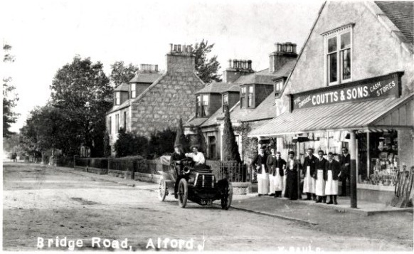
Henry Bell – 1812 – first commercially viable steamship

Robert Napier – 1841 - side level steeple engine. Created Clyde’s reputation for shipbuilding

James “Paraffin” Young – produced crude oil and paraffin from coal

